CENWP-OD-D 10/23/2023

MEMORANDUM FOR THE RECORD

SUBJECT: 23TDA13 TDA gatewell 18-1 steelhead

On 23 October two steelhead mortalities were found in gatewell 18-1. Only one mort could be removed from the gatewell and returned to the river.

- Species – O. mykiss
- Origin – unknown
- Length – ~12”
- Marks and tags – One was PIT scanned
- Marks and Injuries found on carcass – none
- Cause and Time of Death – unknown
- Future and Preventative Measures – none

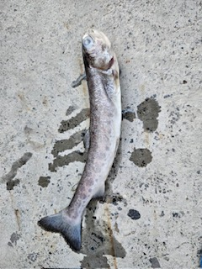

Sincerely,
TDA Project Fisheries

